MODULE 4: S3

Sub-task 1 – Upload resources to S3 bucket

1.Create an S3 bucket which name does not include uppercase characters, includes your full name, and begins with a letter. Recommendation – choose a name generic enough so that the bucket may be reused for developing a web application later.

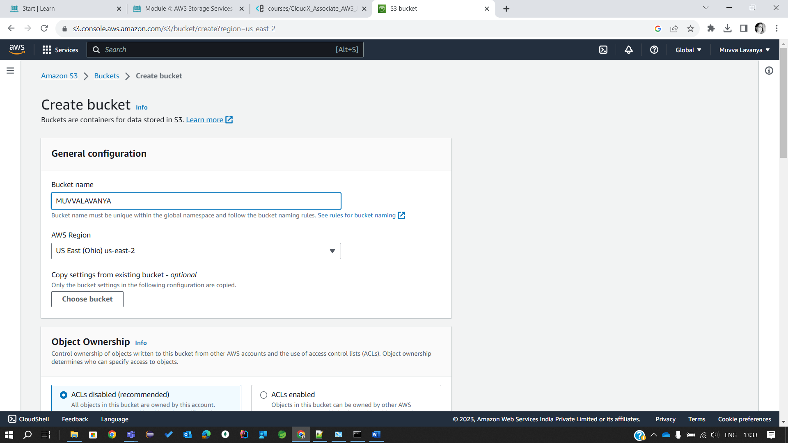

2. Upload some files (images, css fonts, etc...) to the bucket from step 1 using AWS CLI and named profile with appropriate permissions from the previous module.

3. Set the correct permissions. Make sure the uploaded resources in your S3 bucket have public read access. You can do this by setting the ACL to "public-read" when uploading the files or by updating the bucket policy to allow public access to the folders.

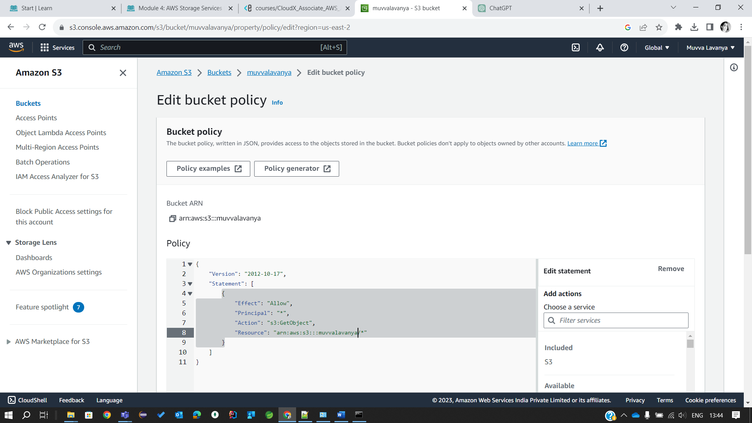

4. Ensure you can access uploaded resources via public Internet. You can find the S3 URL of a file in the AWS Management Console or construct it using the following format: <https://your-bucket-name.s3.amazonaws.com/path/to/your/file>

5. Enable cross-region replication for the bucket from step 2. (! Note: please create a new role when enabling replication, it may not work properly with existing one)

Sub-task 2 – Play with versioning

1. Create another S3 bucket which name doesn’t include uppercase characters, includes your full name + “task2”, and begins with a letter.

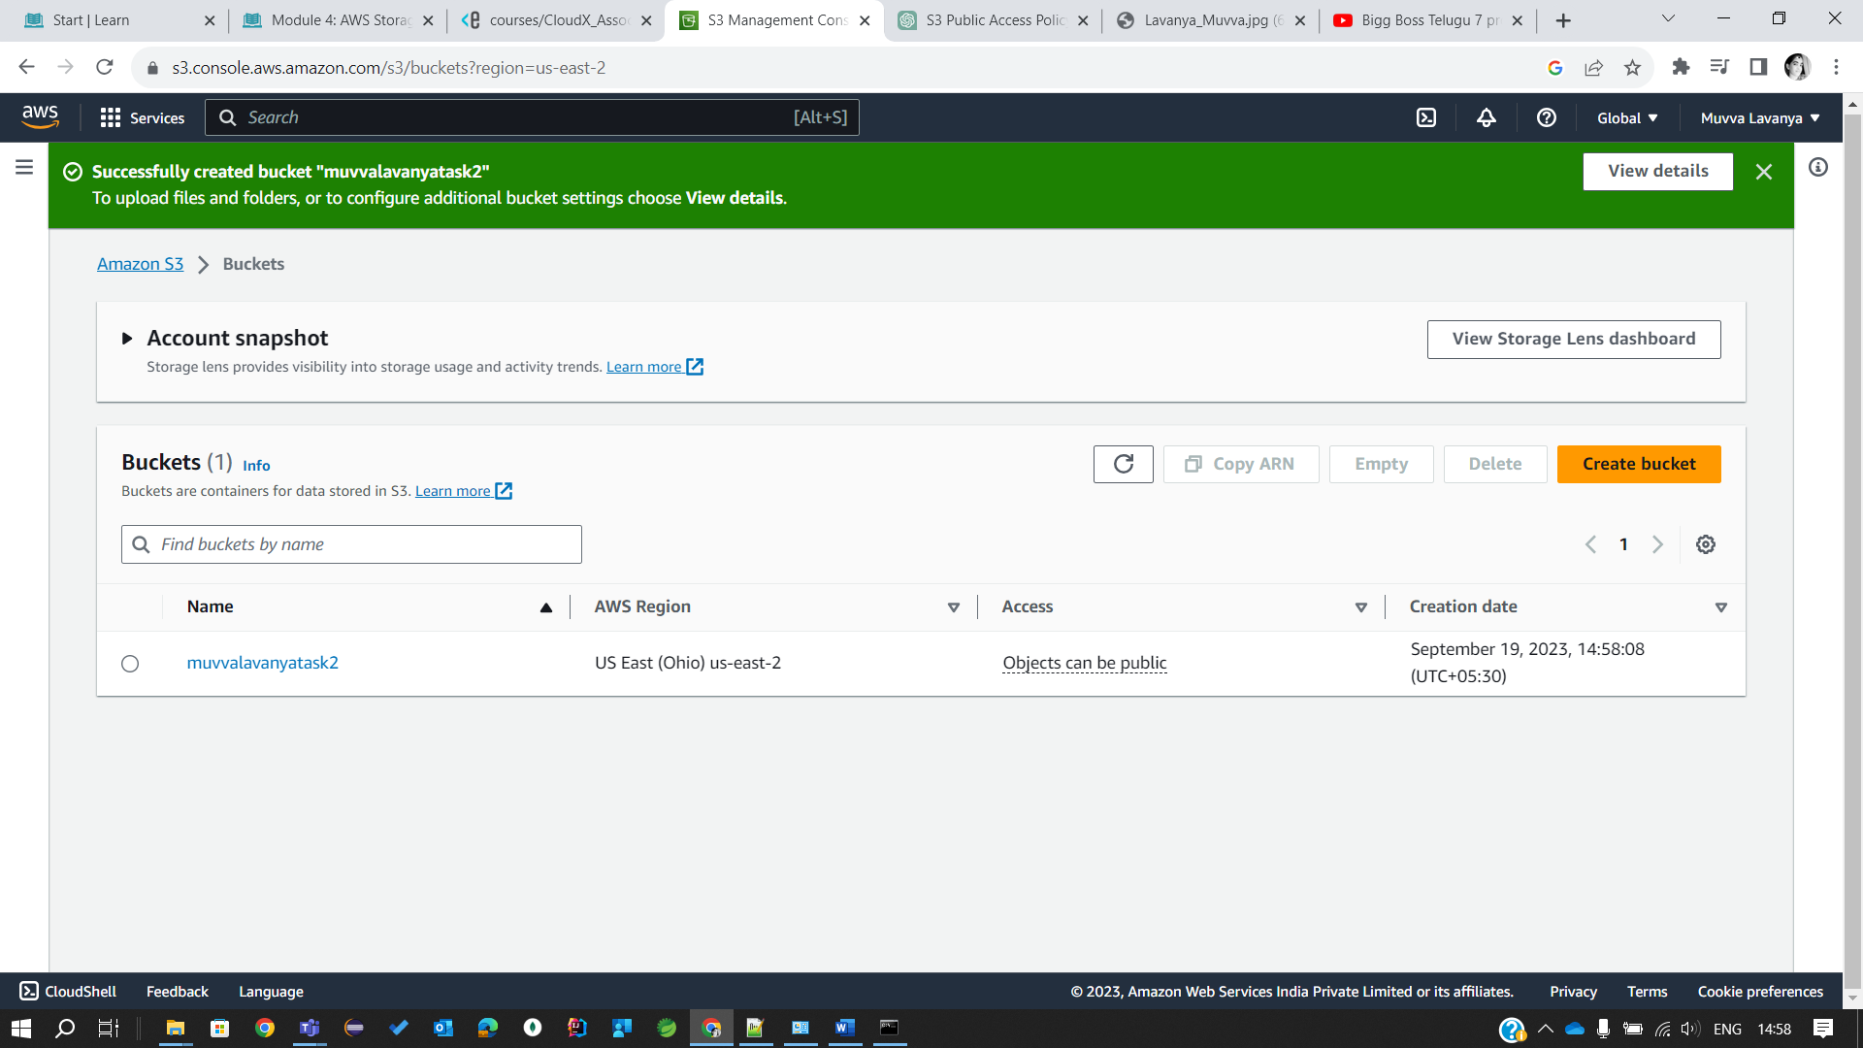

2. Enable versioning for the bucket from step 1.

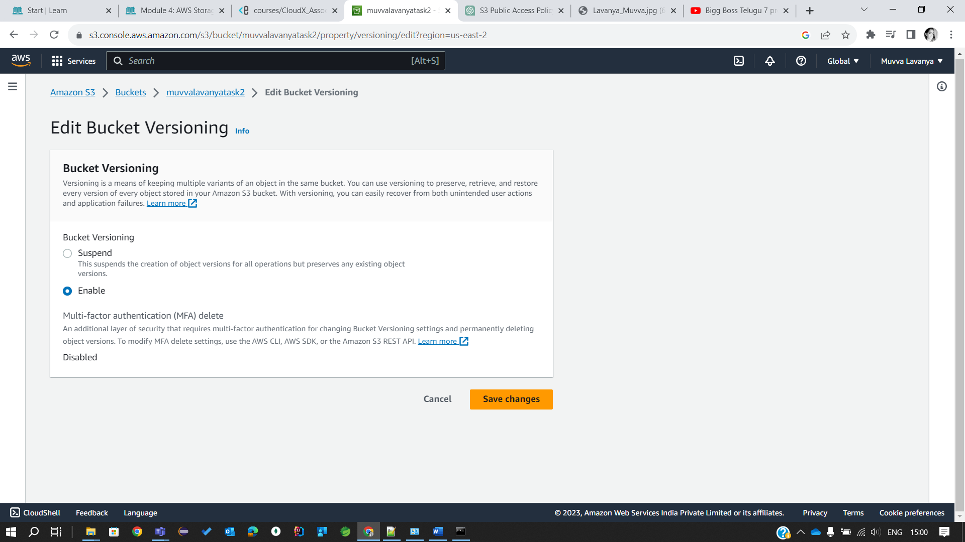

3. Upload 2-3 files to the bucket. Make some changes to these files so that the bucket contains 2 (or more) versions of at least one file.



4. Using AWS CLI, get the latest version of a specific file. 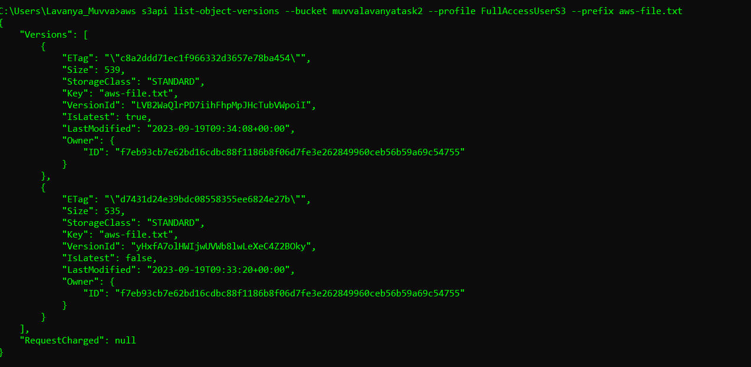

Sub-task 3 – Practice more AWS CLI hacking and play with permissions

1. Using AWS CLI list all the objects in the S3 bucket from the first sub-task of this module. In the response, you'll see a lot of additional data for each object, play with the "--query" parameter to filter out only S3 object keys from the response.

